VOYAGE VISTA : ILLUMINATING INSIGHTS FROM UBER EXPEDITIONARY ANALYSIS

1. INTRODUCTION

1.1 Overview

Uber is a transportation company with an app that allows passengers to hail a ride and drivers to charge fares and get paid.

1.2 Purpose

Connects the physical and digital words to help make movement happen at the tap of a button.

1. Problem Definition & Design Thinking

2.1 Empathy Map

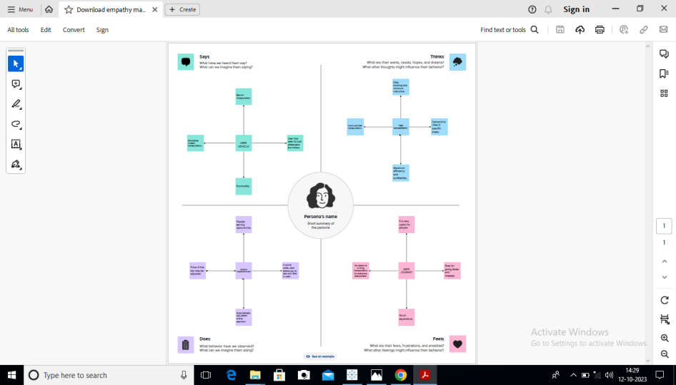

* 1. Ideation & brainstorming Map

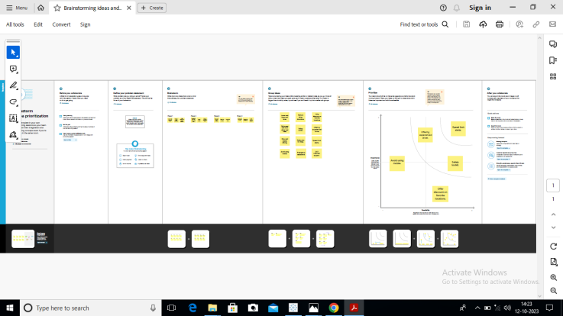

3 RESULT

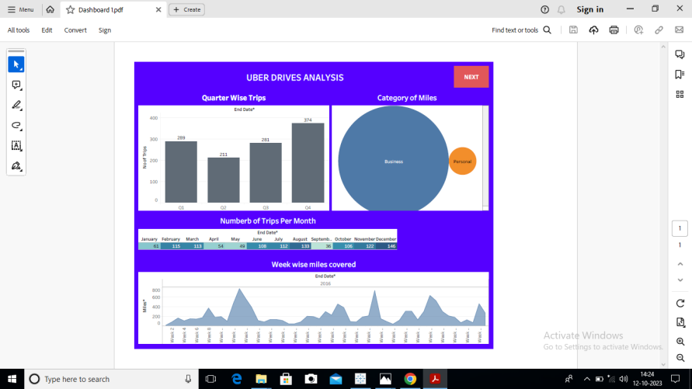

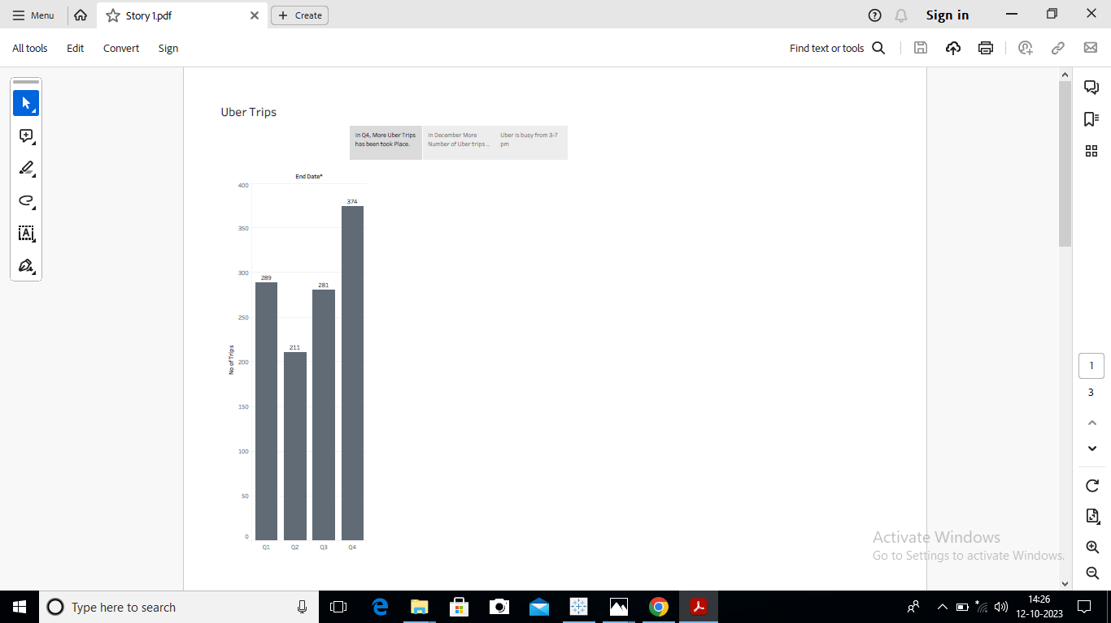

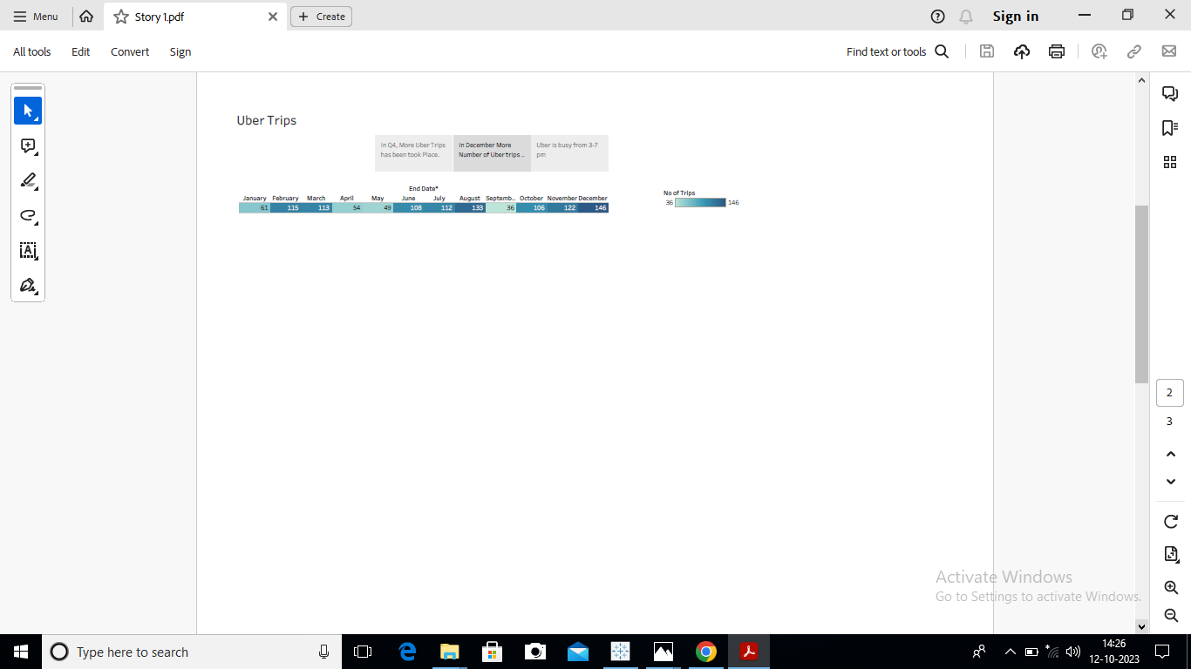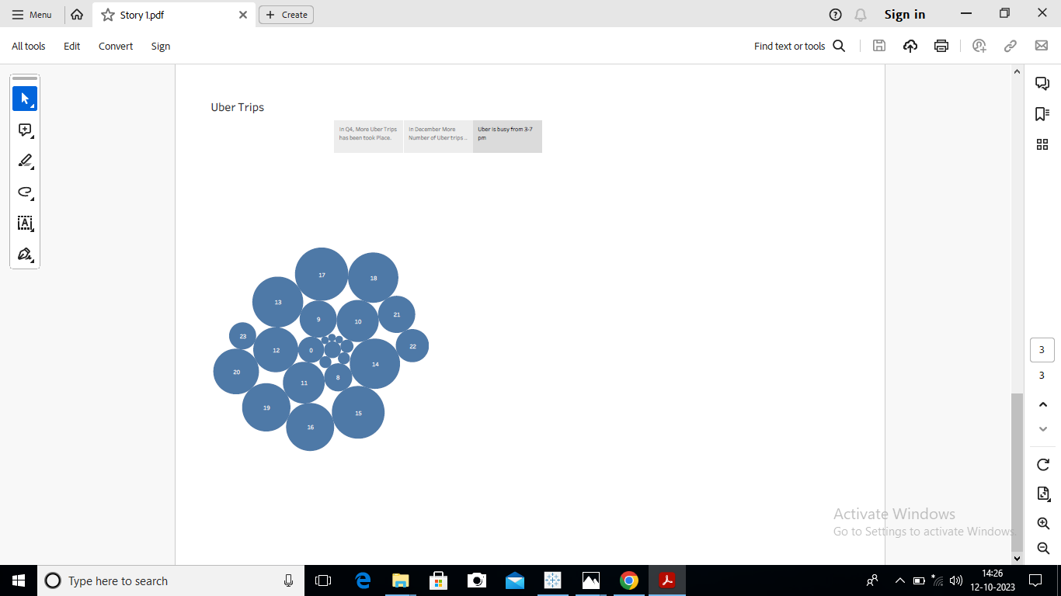

4 ADVANTAGES

* Uber’s advantages include door-to door convenience, safety, and reliable quality.
* Uber customers typically get where they are going faster or cheaper than they would by taxis.
* Convenient and cashless. Safety and flexibility for drivers.

DISADVANTAGES

1. The company has disrupted taxicap business and allegedly caused an increase in traffic congestion.
2. Competition, driver dissatisfaction, financial losses, and safety concerns.
3. Expenses for gas. Maintenance, and insurance.

5 APPLICATION

* Increase Weekly Active riders and Monthly Active riders.
* Increased rides-planning by syncing Google calendar, and offer discount on favorite locations.
* Increase ridership by encouraging riders to sign up for Uber subscribtion packages and, as a byproduct, increase LTV per rider.

6 CONCLUSION

* To improve performance, monitor relationships with suppliers, develop customer relationships, and reduce operational costs.
* It offers incentives and discounts to attract new customers and retain existing ones.

7 FUTURE SCOPE

* Uber plans to have its U.S. fleet and all drivers go electric by 2030.
* To provide transportation as reliable as running water, everywhere, for everyone.
* Aim to serve anyone need for mobility or work-anywhere and anytime.